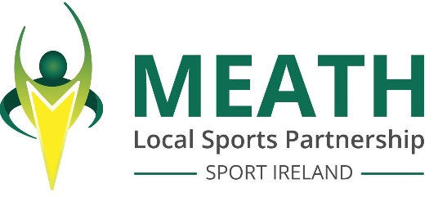

MEATH LOCAL SPORTS PARTNERSHIP
invites applications for the following position:

OUTDOOR RECREATION OFFICER
(THREE YEAR FIXED TERM CONTRACT)

This new role of Outdoor Recreation Officer is central to the realisation of ‘Embracing Ireland's Outdoors’, the National Outdoor Recreation Strategy, and is key to co-ordinating its successful implementation at a county level.
This strategic post will require the officer to work in partnership with relevant statutory bodies and stakeholders in the outdoor sector, with the ultimate aim of increasing the number of people active in the outdoors while ensuring that best practice is implemented.

Job and Person Specification can be downloaded from the Meath LSP website www.meathsports.ie
Please send Cover Letter and Curriculum Vitae to :
mary.murphy@meathcoco.ie

Closing date for receipt of applications is 12noon Thursday 11th April 2024.

Short-listing of candidates may apply. The post is subject to Garda Vetting.
Meath Local Sports Partnership is an Equal Opportunities Employer.



