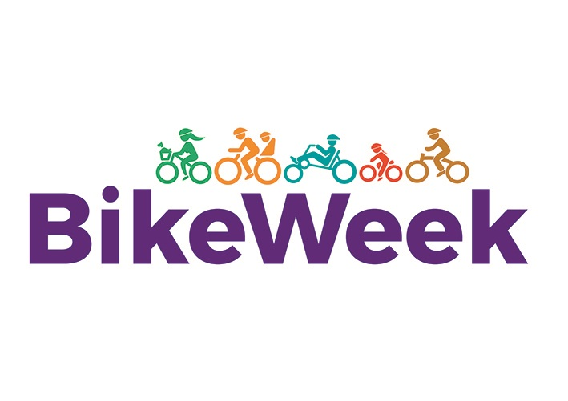
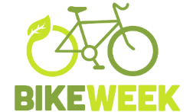
TERMS & CONDITIONS
BIKE WEEK APPLICATION

PLEASE READ THE FOLLOWING TERMS AND CONDITIONS CAREFULLY BEFORE SUBMITTING AN APPLICATION FOR BIKE WEEK FUNDING 2022
Overview of Bike Week Funding:
The overall aim of Bike Week fund is to provide support to clubs, schools, voluntary groups or communities who wish to deliver events during Bike Week 2022. The goal of bike week is to encourage more people to get out on a bike. Bike week celebrates cycling – events can be aimed at families, leisure cyclists, communities or specific population types (older people; people with disabilities; women only cycles etc).

Criteria:
- Events must be held during Bike Week 2020: 14th to 22nd May 2022
- All events must be FREE to the public/participant.
- Meath LSP & Bike Week logo must be used on all materials (Evidence must be provided of same).
- Only events/organisations based in Meath are eligible to apply for funding under this scheme.
- Event insurance: The applicant group is solely responsible for ensuring adequate insurance cover is in place to provide full insurance of the planned event. You may be required to submit evidence of insurance cover. We advise all groups to contact their insurers prior to submitting an application.
- Adherence to Child Protection Guidelines: Where children or young people are participating as part of the event, organisers should familiarise themselves with Cycling Ireland's 'Code of Practise and Safeguarding Procedures for Young and Vulnerable Cyclists' which can be found at http://www.cyclingireland.ie/downloads/ci%20code%20of%20conduct.pdf. Events for children and young people should ensure a ratio of at least 1 adult to 6 children with a minimum of 2 adults per group.
- Bike Week funding supports are awarded towards the organisation and running of events and not for capital investment projects, such as the construction of bike stands or the purchase of bicycles.
- Funding should not be provided for existing events (this is not a source of funding for clubs / organisations; accordingly funding for their own events, club rides, sportives etc. should be avoided).
- This application process requires submission of an outline proposal (see application) to Meath LSP/Bike Week Steering Committee for approval.
- A dedicated contact person from your organisation should be appointed. Full details for that contact person (email address and telephone number) must be submitted as part of this application process.
- If required, a member of staff from Meath Local Sports Partnership may have a pre event meeting with this contact person to assist with planning of the event in question.

To be eligible for funding, you must:
- Use the funding provided for the purpose outlined in your application
- Provide feedback by way of a report to Meath LSP detailing your event activities, numbers attended – photos, press release, promotional flyers etc will all form part of the report process.
- You must provide invoices/receipts showing expenditure. Only expenditure which has been agreed as part of the application will be deemed eligible
- Events should place emphasis on participation rather than competition
- Applicant must ensure that there is appropriate medical cover in place at all times during the event
- Have capability to promote the event
- Show how Covid-19 protocols will be implemented and adhered to at all times e.g. recommended numbers, social distancing, sanitation etc.
- Upload the event on Meath LSP facebook & website
For the purposes of the funding, eligible expenditure will include:

- Costs involved in organising local fun cycling events for public participation
- Costs involved in organising public information events on cycling;
- Costs of purchase of items such as lights, locks, bells etc to raffle or give as prizes for participants in events;
- Costs of complementary activities for event days, e.g. musical entertainment, face painting, novelty bike displays
- Costs relating to publicity for events.
- Costs incurred in provision of cycling training *
*Please note this is to a maximum of €500 – clubs who apply will be awarded more marks.

Funding is available to a maximum of €500
You will need to ensure that your organisation has the capacity to absorb the costs of organising this event (paying invoices to suppliers etc.) until such time that the payment of the funding support..

There is no guarantee of funding for events which achieve the minimum eligibility criteria. The fund is limited and eligible applications will be evaluated on a competitive basis against the criteria being applied.
Considerations:
- Mainly consider activities that comply with current restrictions (hopefully additional restrictions will not be introduced or the current restrictions may be eased by the time of BW).
- Consider splitting events over a number of days (Bike Week lasts for 9 days)
- Reduce the social aspect of events, not only during but also before and after any event (virtual, individual and small groups are less likely to be impacted by Covid).
- Flexibility exists for you to change events as you consider necessary, within the funding allocated.
- Finally and most important, please ensure everyone involved in and/ or organising the Bike Week activity is aware of and complies fully with COVID-19 restrictions - all activity must comply with whatever restrictions are in place at the time, please check regularly the general advice and advice specific to your area is available.

